Philip Trinh

SNHU/ CS330

01 July 2023

CS 330 Module One Assignment

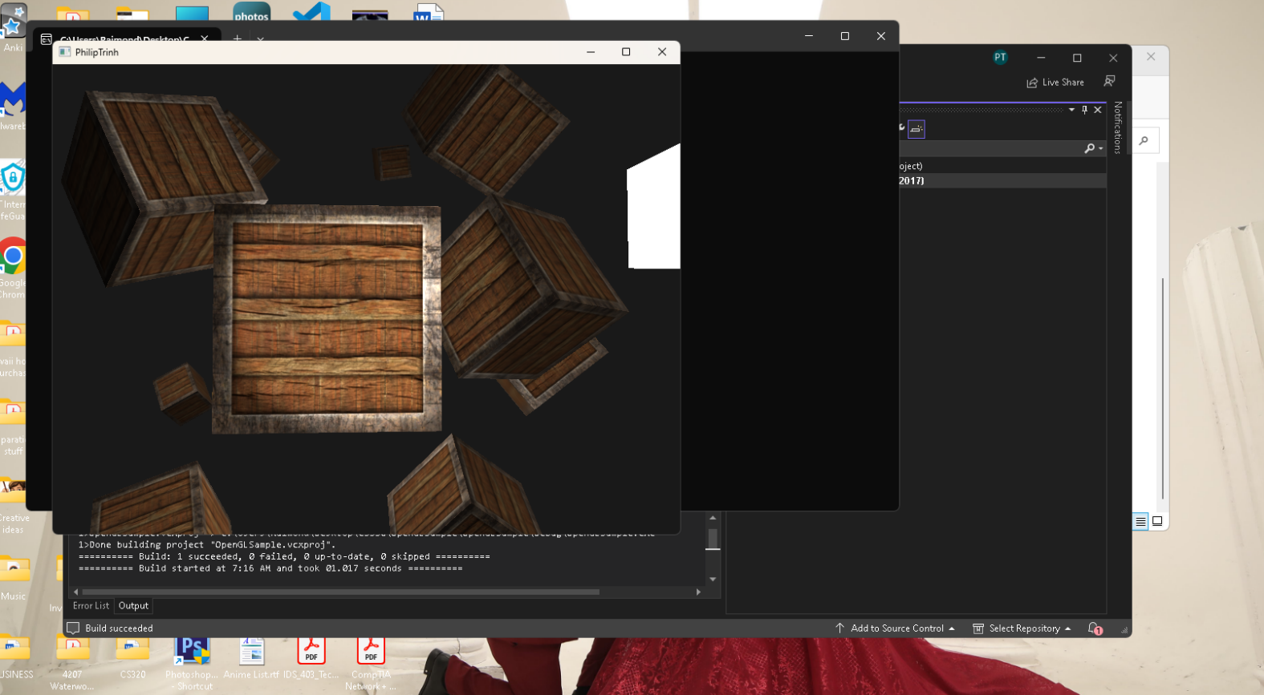In this assignment I began by downloading the two zip files included in the 1-1 set up and then followed the tutorial pdf and watched the video provided. I ran into a few errors code since I am running version Visual Studio 2022. I didn’t want to upgrade the provided SampleOpenGL file to match my edit version in worries because it will affect future processing as it did with my other project in the past. After looking up a solution I was able to download optional installation for 2017 and 2019 Visual Studio edit and .NET frame from modify the Visual Studio Installer. Also, another problem I ran into is that the system defaults to uncheck the box “Inherit from parent or project defaults” of Include directories and Library directories from the Property. This has caused compilation and built error and prevent changes made to source.cpp. I came back to the property to check and mark these boxes and I ran without any problem afterward. Below is the screen shot of the running program.